

Trash mixed in with the incoming soil from the hospitals is an on-going issue at HCSA. Here are some examples of the challenges we face at the laundry facility as our staff works hard to provide clean linen for your patients each day.

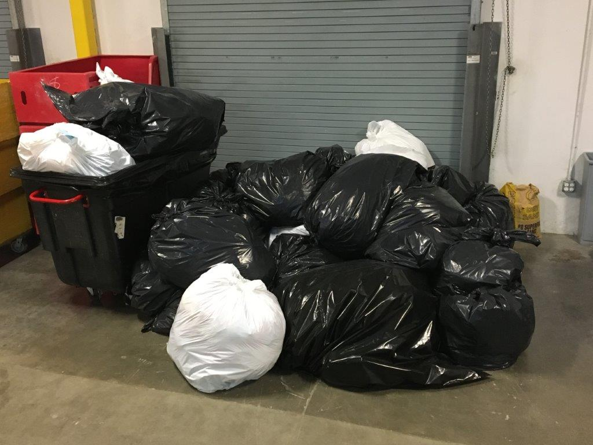

This is the trash collected in just one day at laundry plant, located in Auburn, WA.

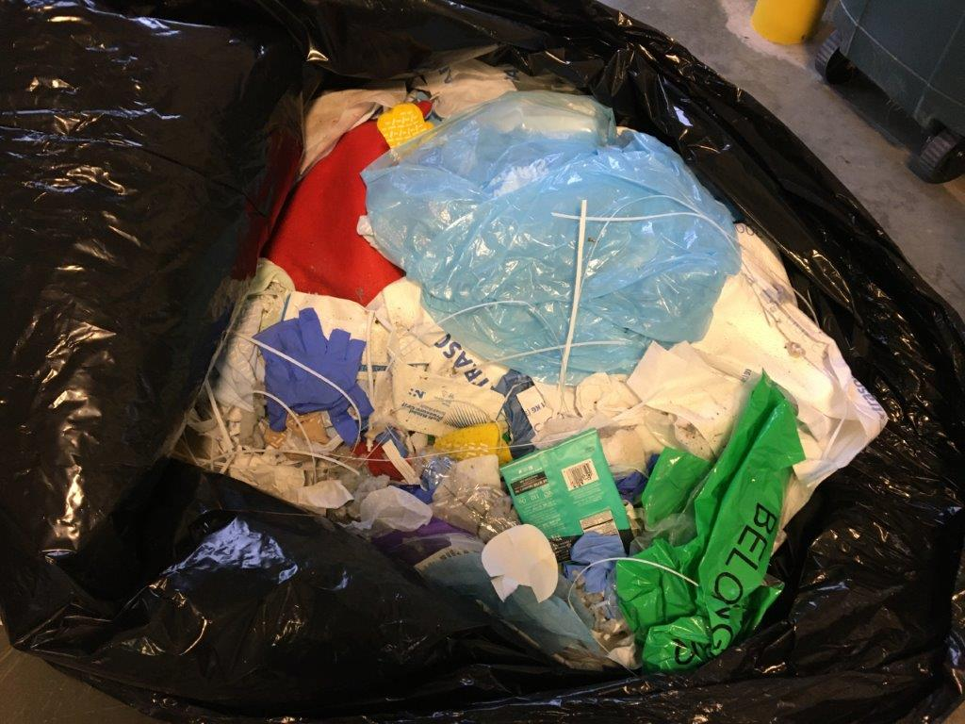

Here’s a closer look at the kinds of trash that gets mixed in with the soiled linen.

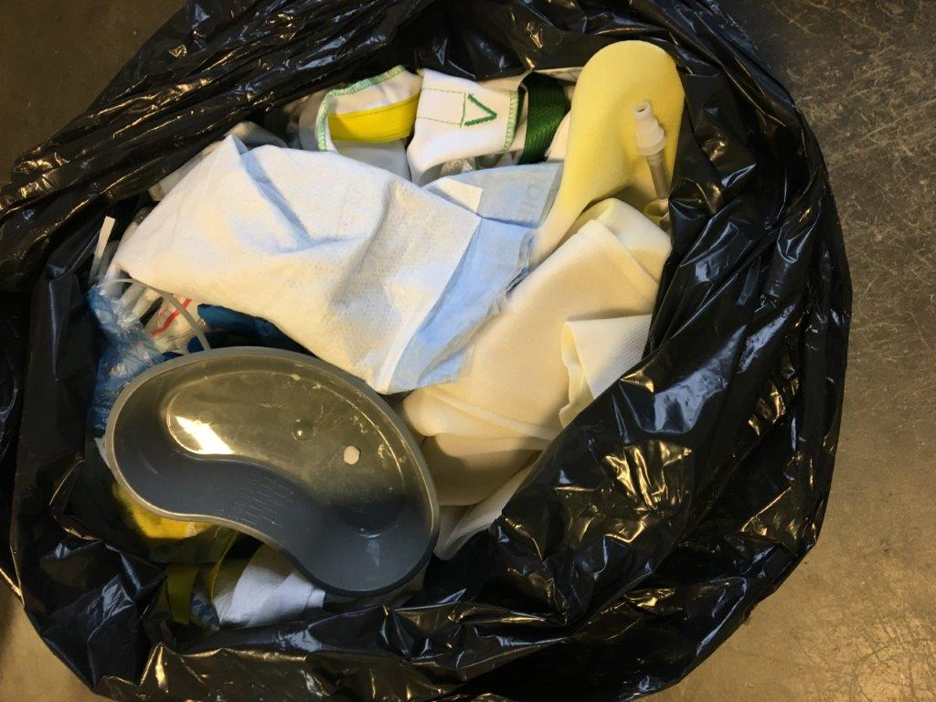

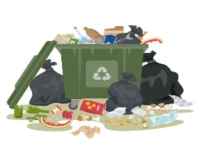Much of the debris found at the plant could be recycled and kept out of the landfills if properly sorted at the hospitals.

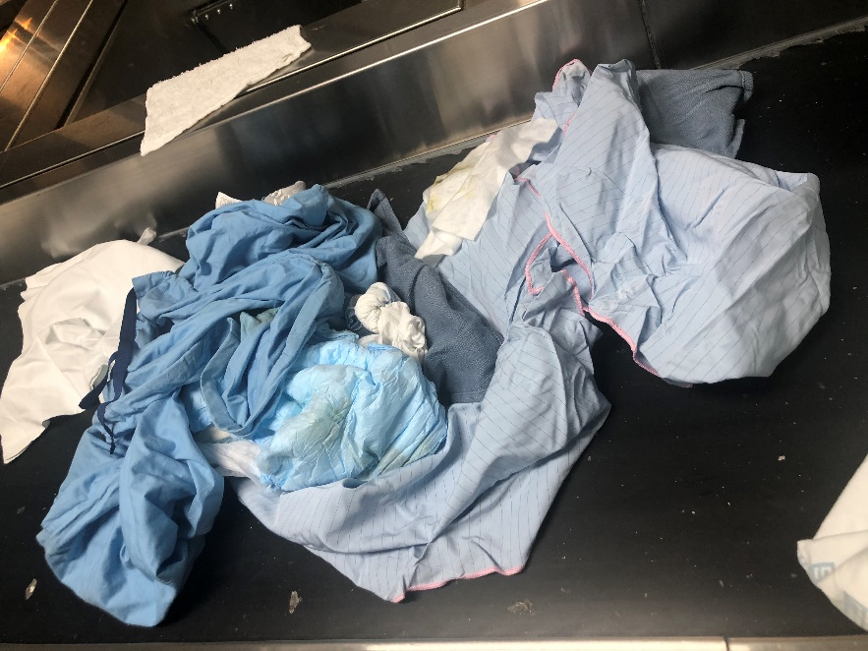

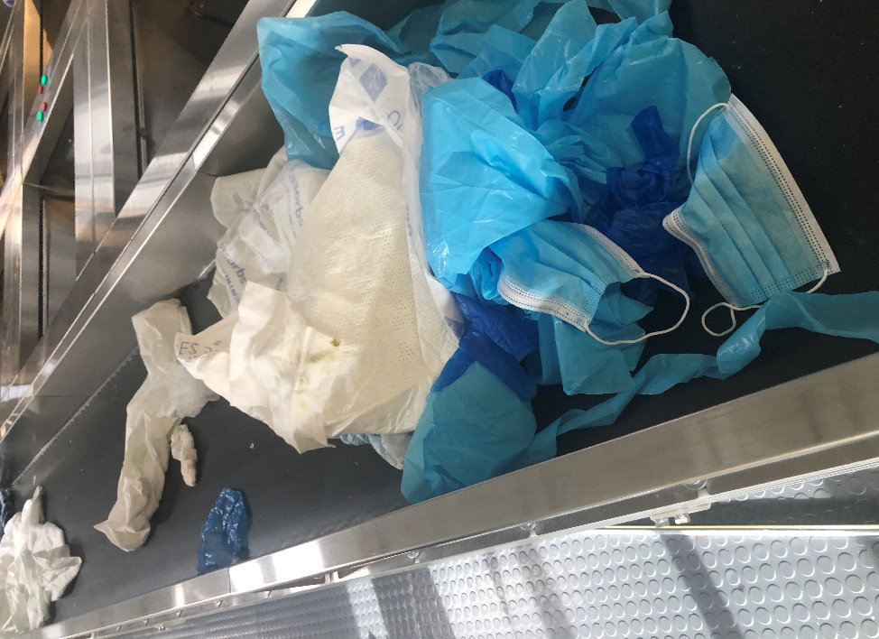

Here we see trash being separated from the soiled linen on the soil sort conveyor belt at our facility.



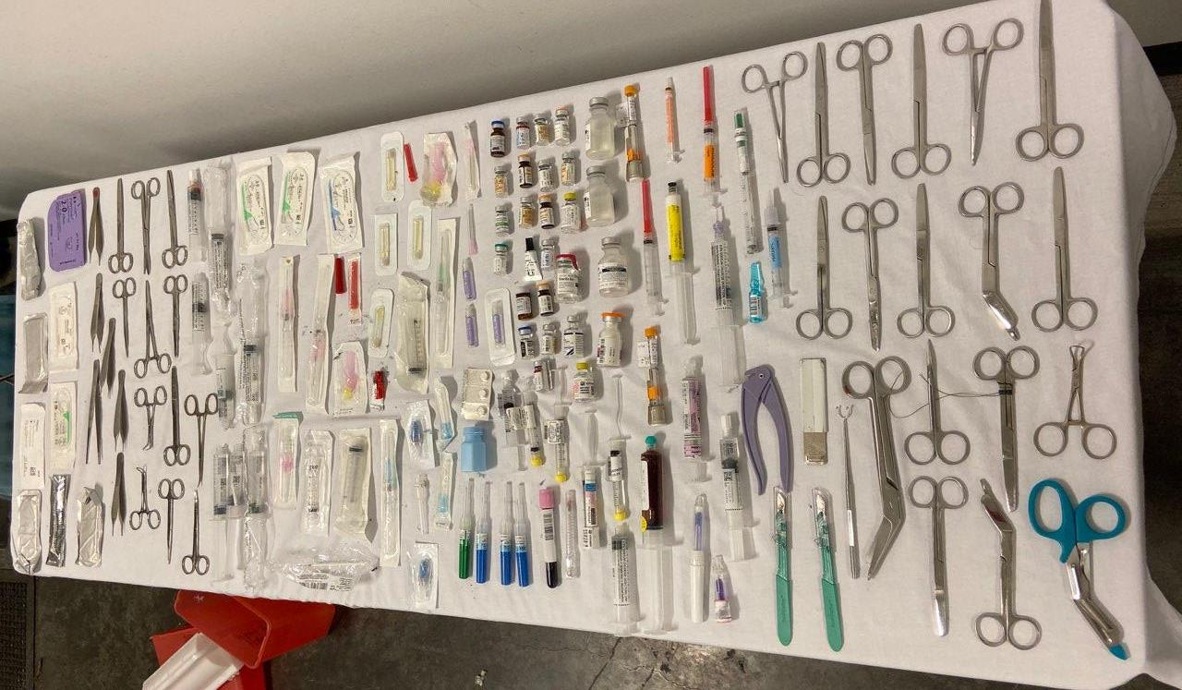

Pictured above is one month’s worth of sharps, drug and medical equipment collected from the pockets of scrubs.

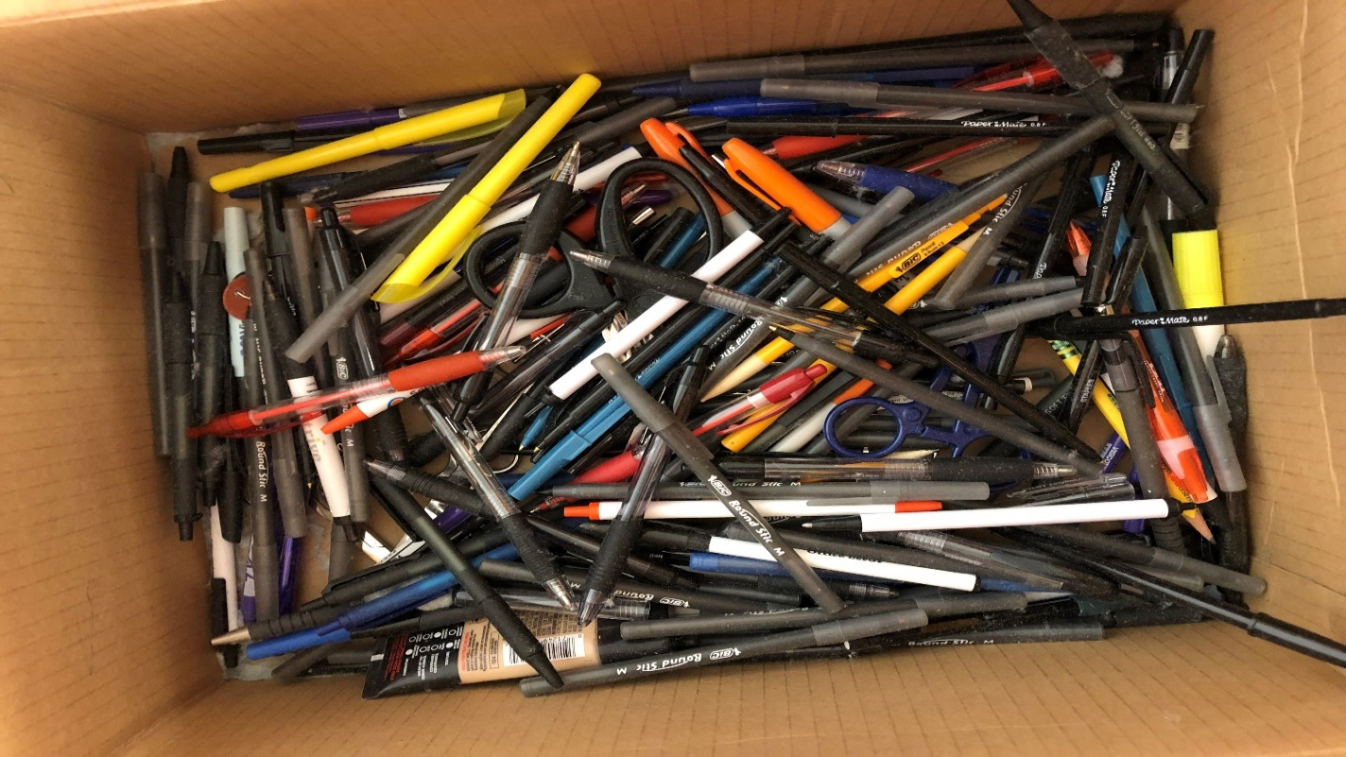

Pens, pencils and highlighters are also collected in large quantities after being left in scrub pockets. Just one pen can be ruin an entire load of scrubs with ink stains. One load contains approx. 500 pieces at a value of $3000. HCSA processes an estimated $70,000 worth of scrubs every day.

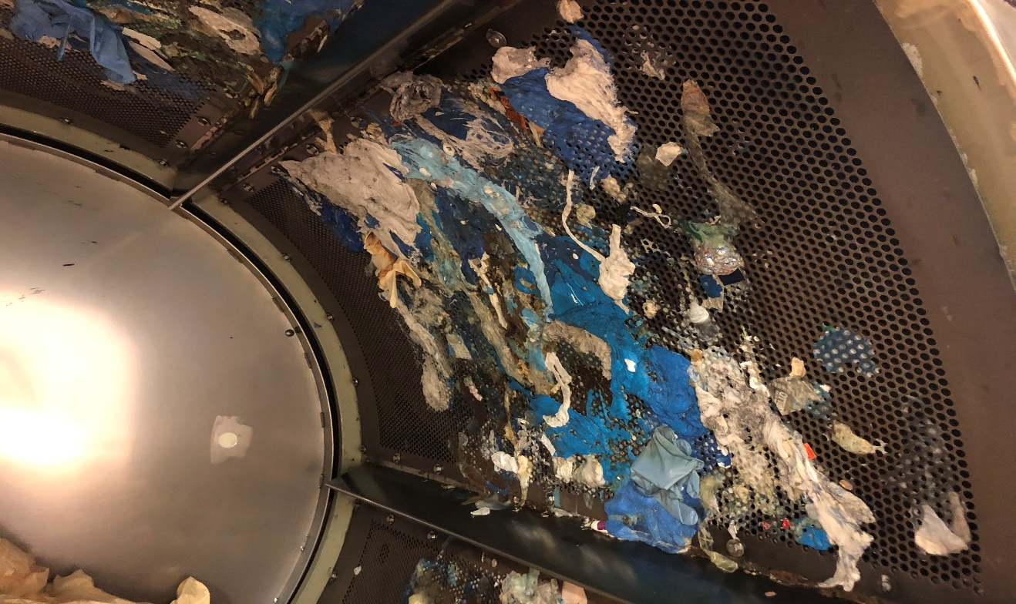

This picture shows the inside of just one of the 16 dryers in our facility. What you are looking at is melted plastic stuck to the inside of the metal drum. Reduces dryer efficiency and uses more gas to dry the linen. The melted plastic will not come off easily. The panels must be removed and shipped off-site to be sand-blasted, a new coat of Teflon coating applied, then shipped back for reassembly.

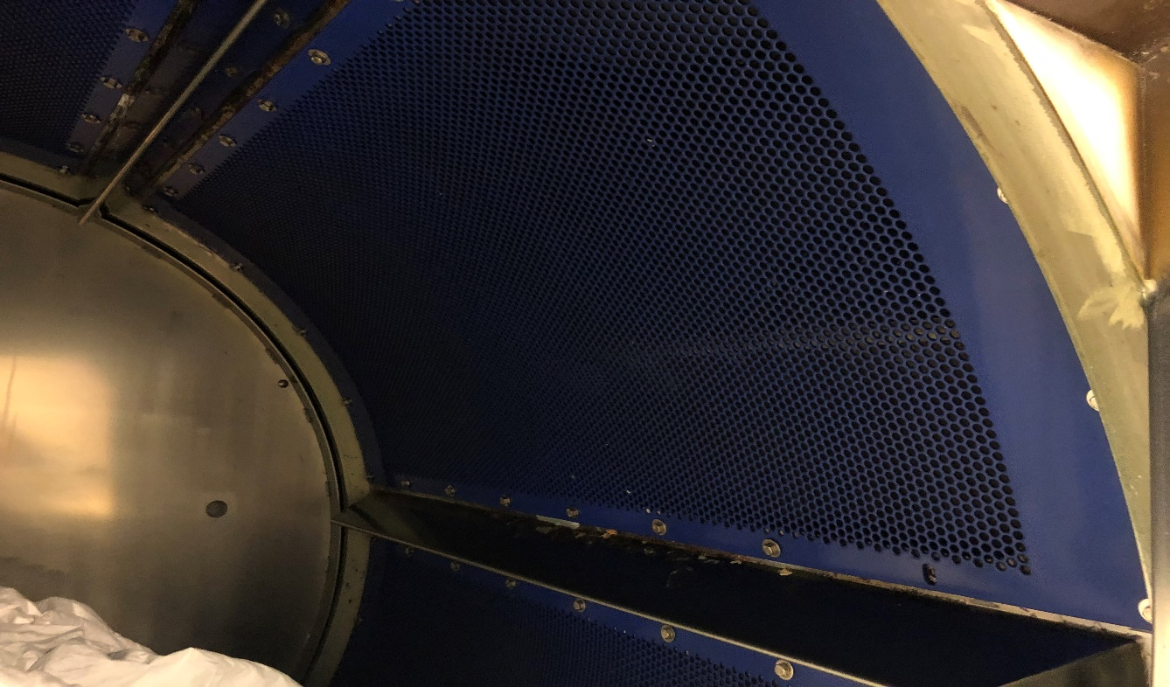

Here’s an example of a dryer panel after it’s been repaired and all the melted plastic has been removed. This process is costly and occupies man hours and lost equipment time. We repair approximately 96 panels each year at cost of $110 each for an annual expense of $11,616.00.

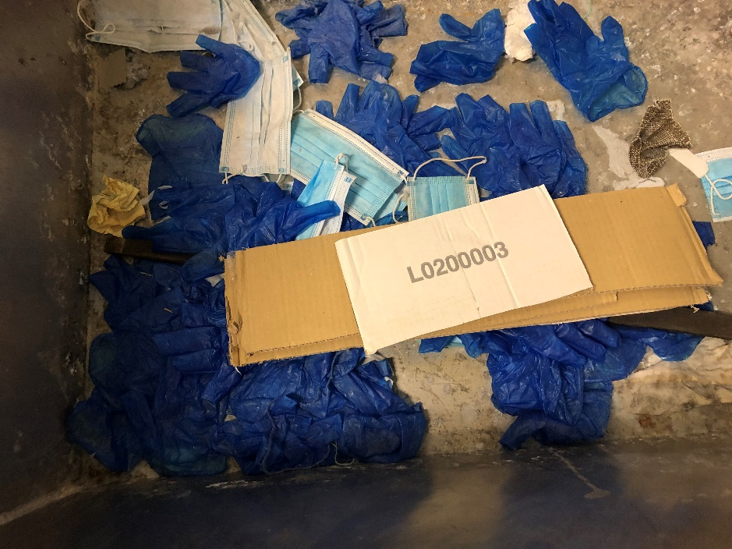

We receive hundreds of latex gloves at our facility each day.

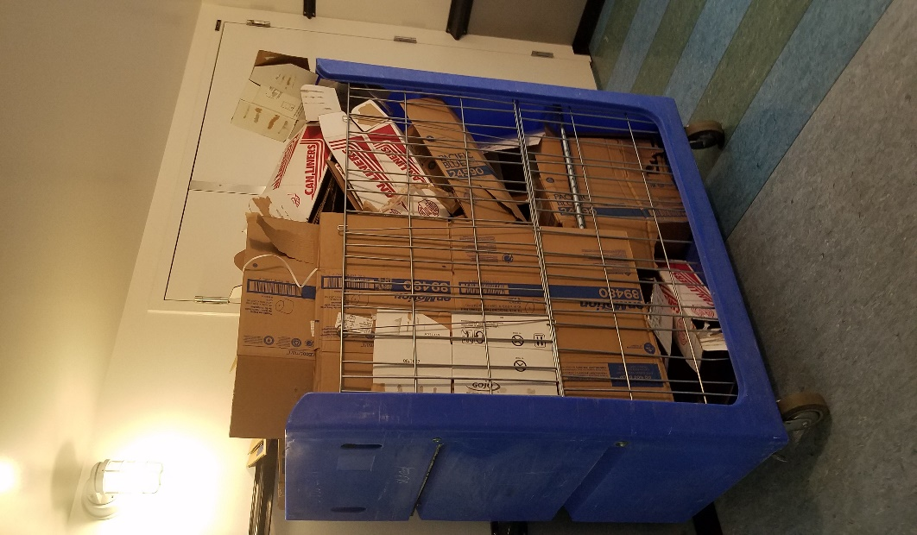

HCSA linen carts should not be used for trash collection within hospitals or clinics. These carts need to be kept in circulation for use across the HCSA consortium; and should only be used for clean linen deliveries and promptly unloaded for soiled linen collection purposes.